ETISALAT Fusion PMS Application Setup

Table of Contents

1. New Role for Sales Department 2

2. Document of Record for Basic Salary Details 5

3. Role Delegation 8

4. New HSDL for Adhoc payments and Basic Salary Details 13

5. Accrual Changes for New joiners 17

## New Role for Sales Department

Role Name: ETC CS HRSPOC Restricted:

Navigation: Tools > Security Console > Roles

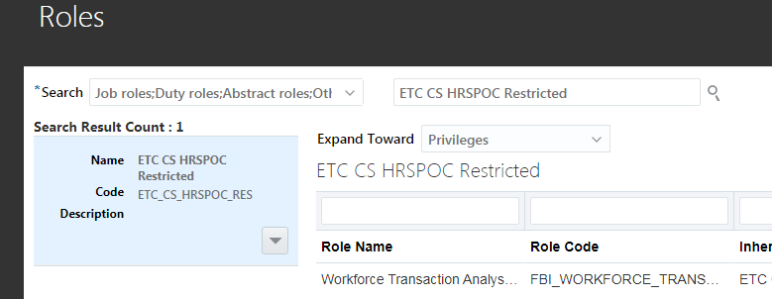

Person Security (used existing one: ETC HRSPOC Consumer Sales):

Navigation: My Client Groups > Workforce Structures > Security Profiles > Person Security Profiles > ETC HRSPOC Consumer Sales

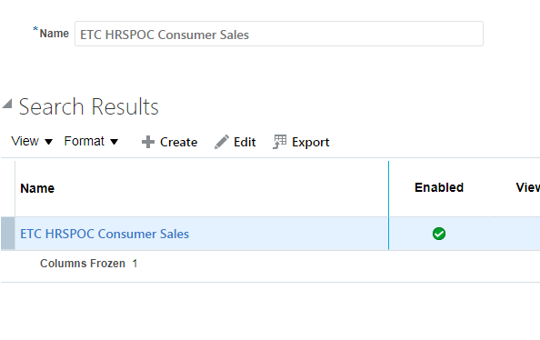

Data Role and Security (ETC CS HRSPOC Restricted):

Navigation: My Client Groups > Workforce Structures > Data Role > Data Roles and Security Profiles > ETC CS HRSPOC Restricted

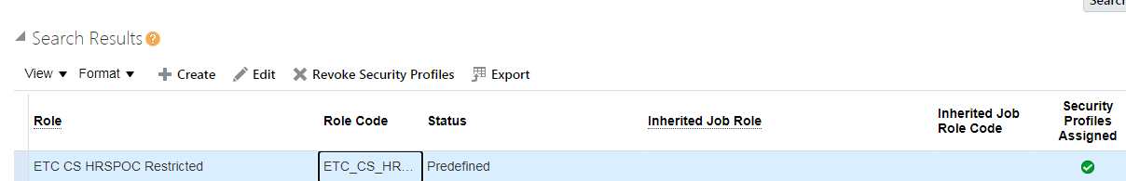

Personalization:

Login with Administrator user > Create and Activate a sandbox > My client groups > Show More > Employment > Change Assignment > Search a Person > Select and Continue > hide the below fields from personalization structure

Business Unit

Job

Business Title

Department

Enable DFF and hide extra fields keep only Attendance source.

Steps to hide DFF segments:

Login with Administrator user > Create and Activate a sandbox > My client groups > Show More > Employment > Change Assignment > Search a Person > Select and Continue > go to structure select DFF > Properties > Flexfield Global Context Segments > select each segment one by one and make its Rendered ‘false’ > Apply and Ok > verify the changes and publish the sandbox.

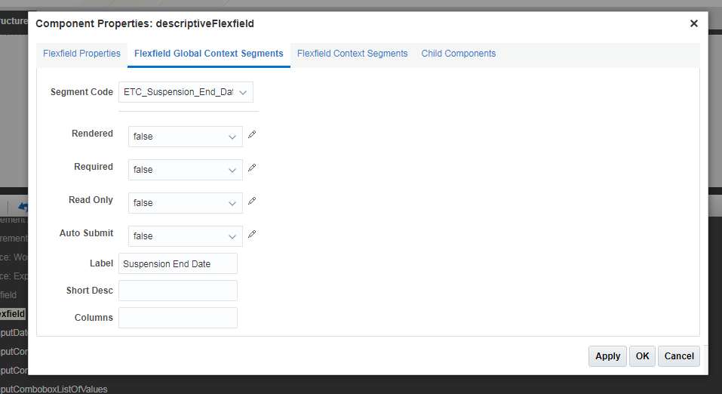

Hide ‘Change Legal Employer’ Quick Action:

Navigation/Steps: Create and Activate a sandbox > Navigator > Configuration > Structure > My Client Groups (click on My Client Groups)> Quick Actions > Employment > Change Legal Employer > in ‘Visible’ select ‘No’ > Save and Close > verify your changes and publish the sandbox

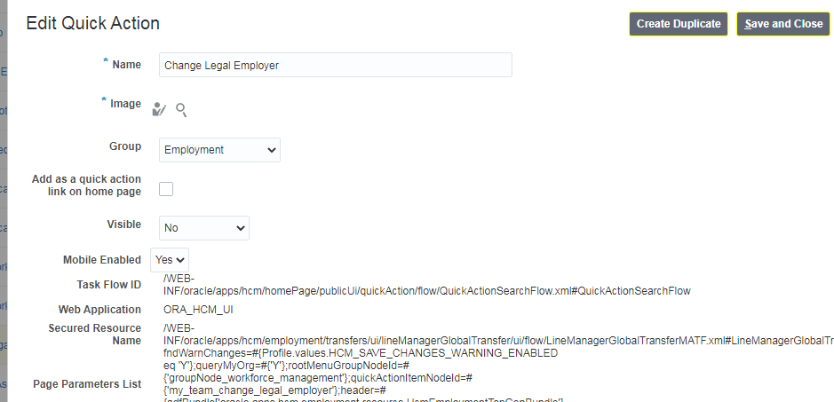

## Document of Record for Basic Salary Details

Navigation: Navigate to Setup and Maintenance > Tasks > Search > Define Documents > Document Type

Document Name: ETC Salary Details

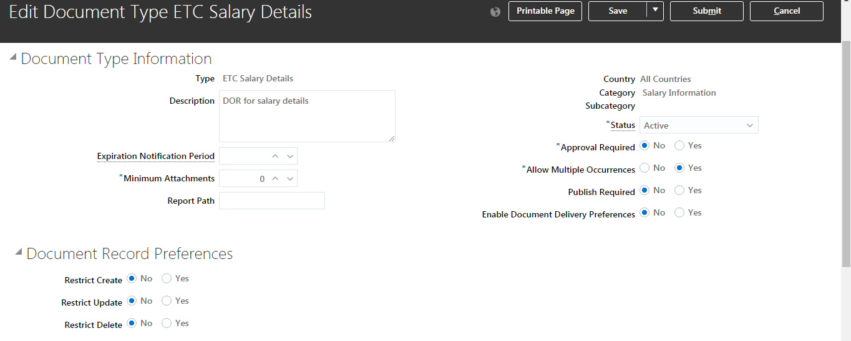

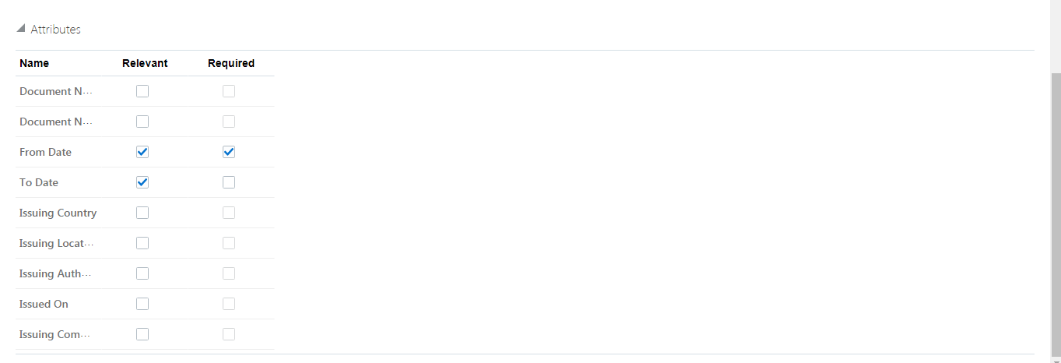

DOR DFF:

Navigation: Navigate to Setup and Maintenance > Tasks > Search > Define Documents > Document Records Descriptive Flexfields < Edit > Manage Contexts > Add

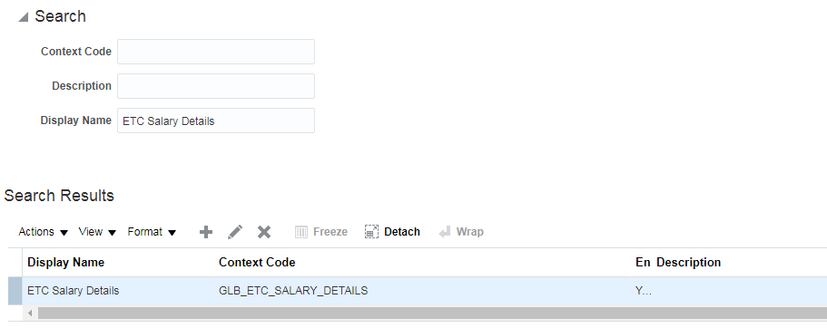

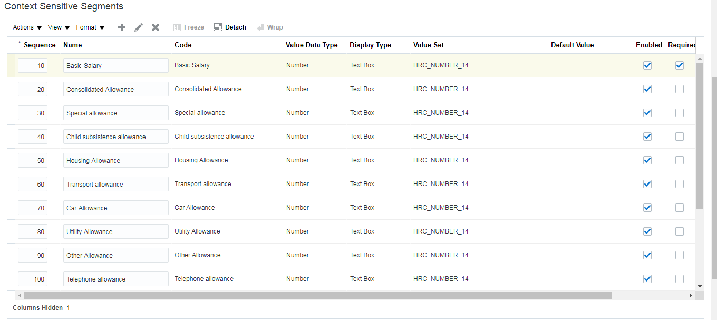

Below Salary Components have been added as per HR instruction.

|  |  |  |
| --- | --- | --- |
| fields required | detail | Included in gross salary |
| Basic Salary |  | yes |
| Consolidated Allowance |  | yes |
| Special allowance |  | yes |
| Child subsistence allowance |  | yes |
| Housing Allowance |  | yes |
| Transport allowance |  | yes |
| Car Allowance |  | yes |
| Utility Allowance |  | yes |
| Other Allowance |  | yes |
| Telephone allowance |  | yes |
| cost of living allowance |  | no |
| Education allowance |  | no |
| air fare/Annual ticket | single/family | no |
| Insurance | single/family | no |
| Pension |  | no |

Adding New DOR to security profile:

Navigation: My Client Groups > Workforce Structures > Security Profiles > Document Type Security Profiles > Add the new DOR in below two security profiles

* ETC Documents Of Record
* ETC AGENCY DOR

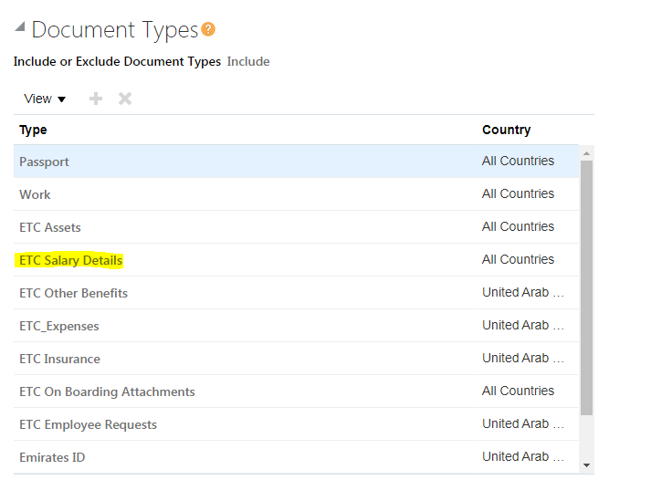

## Role Delegation

Privileges added in ETC Line Manager Role.

* Manage Role Delegations
* View Role Delegations

Navigation/Steps: Tools > Security Console > Roles > search for ETC Line Manager Role > Edit Role > Role Hierarchy > Add the above to Privileges > Next > Next > Save and Close.

Profile Option Setting:

Navigation: Navigate to Setup and Maintenance > Tasks > Search > search for Manage Administrator Profile Values > set the below profile option to ‘Y’

Profile option name: Role Delegation Send Notifications

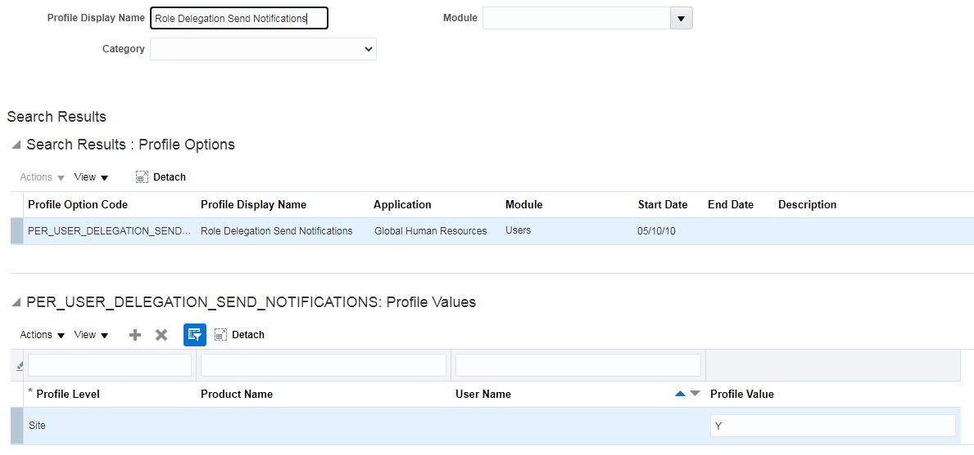

New Person Security:

Navigation: My Client Groups > Workforce Structures > Security Profiles > Person Security Profiles > Person Security profile name: ETC Role Delegation Person Security Profile

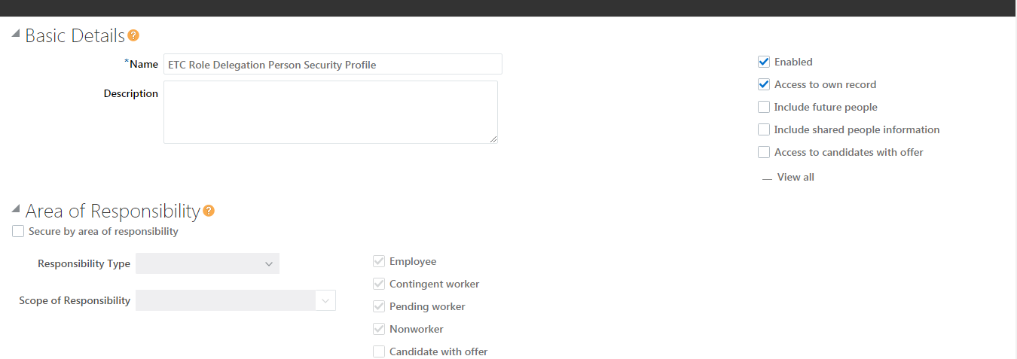

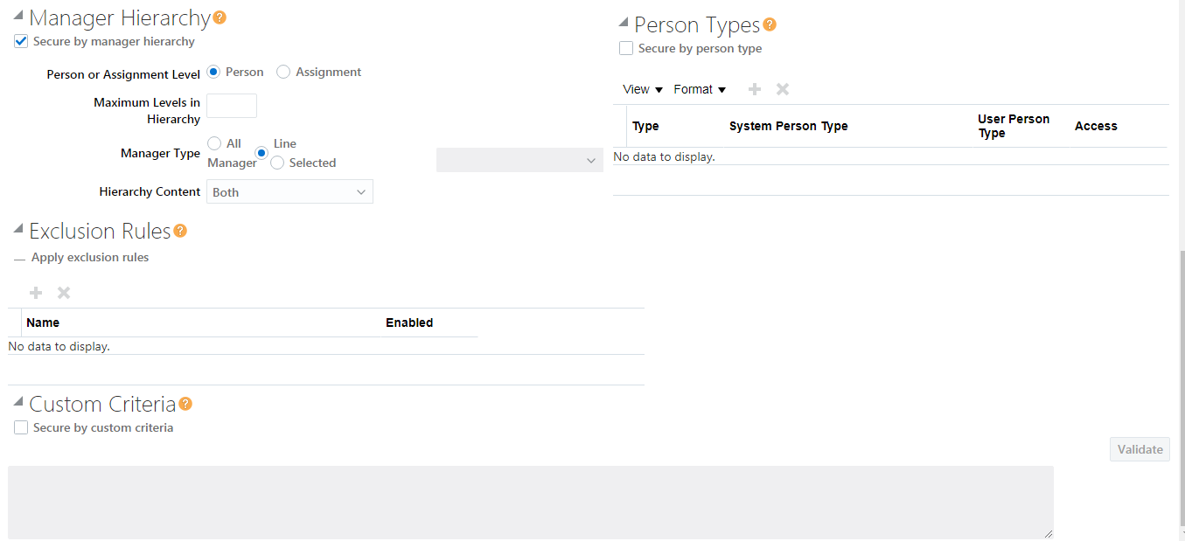

Add the New person security profile to ETC Line Manager from Data Role and Security

Navigation/Steps: Navigation: My Client Groups > Workforce Structures > Data Role > Data Roles and Security Profiles > ETC Line Manager > Edit > check Delegation Allowed check box > Next > Yes > in Person Security Profile select the newly created security profile > then complete process by selecting next, next and submit at the end. > Run the below mentioned programs

* Import User and Role Application Security Data
* Retrieve Latest LDAP Changes

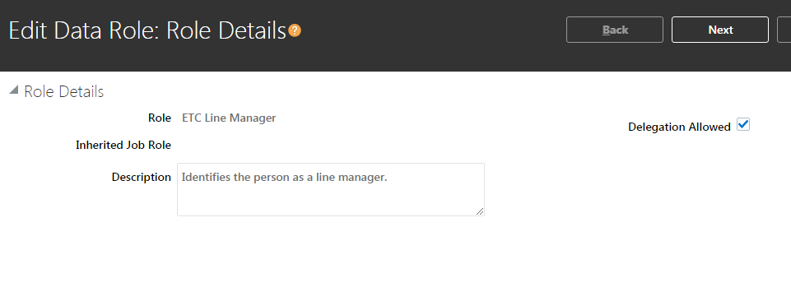

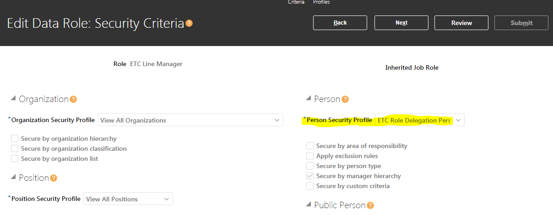

Personalization for Admin screen:

Login as Administrator > create and activate a sandbox > my client groups > Person management > Search any employee > personal and employment > user account > edit pages > structure > select role delegation area > search and select **panelSectionEdit[Close]** > Properties > changes El expression for Edit Rendered to true > Apply and OK > verify your changes and publish the sandbox .

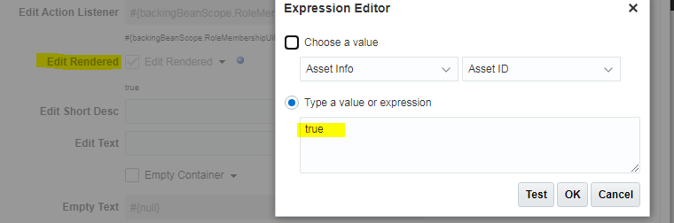

New Short cut link for Vacation Rule:

Navigation/Steps: create and activate a sandbox > Me > Role and Delegation > Navigate to Edit Pages > Structure > select area where person number is displayed > click + sign from structure > Open Components > Add Hyperlink > select the create Hyperlink > click properties > in Destination enter the link of Vacation rule > then go to display option enter other details and below screen shot > Apply and OK > verify your changes and publish the sandbox

Clone Instance Link: <https://ejdq-test.fa.em2.oraclecloud.com/integration/worklistapp/faces/preferences.jspx?_afrLoop=4152312512514978&_afrWindowMode=0&_afrWindowId=10k0chrpry&_adf.ctrl-state=zehv7dett_10&_afrFS=16&_afrMT=screen&_afrMFW=1024&_afrMFH=721&_afrMFDW=1366&_afrMFDH=768&_afrMFC=8&_afrMFCI=0&_afrMFM=0&_afrMFR=96&_afrMFG=0&_afrMFS=0&_afrMFO=0>

Note: take prod instance link for PROD.

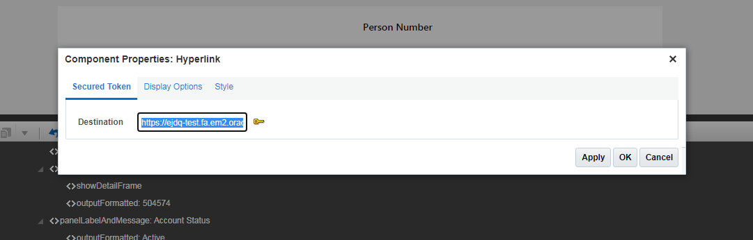

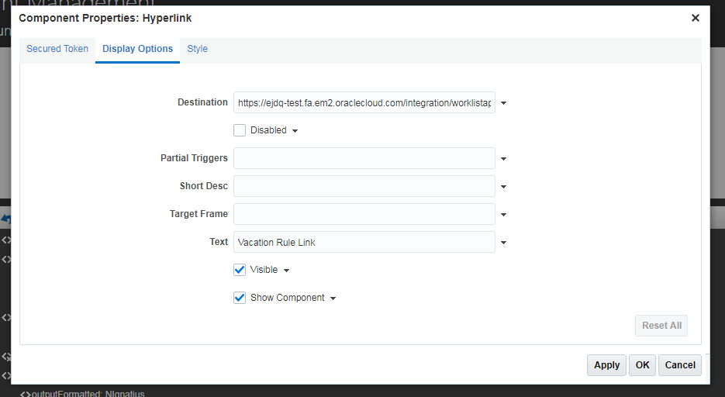

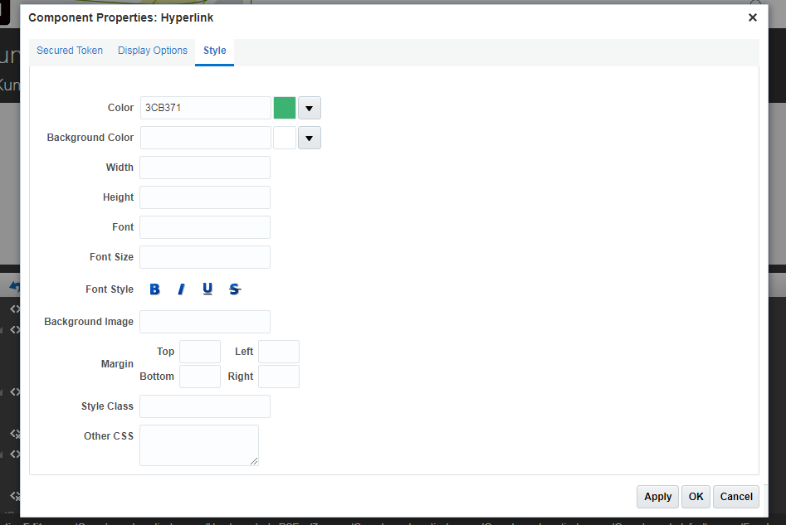

## New HSDL for Adhoc payments and Basic Salary Details

Navigation: My Client groups > Data Exchange > HCM Spreadsheet Data Loader > Spreadsheet Templates > Create

HSDL: ETC Salary Details Upload

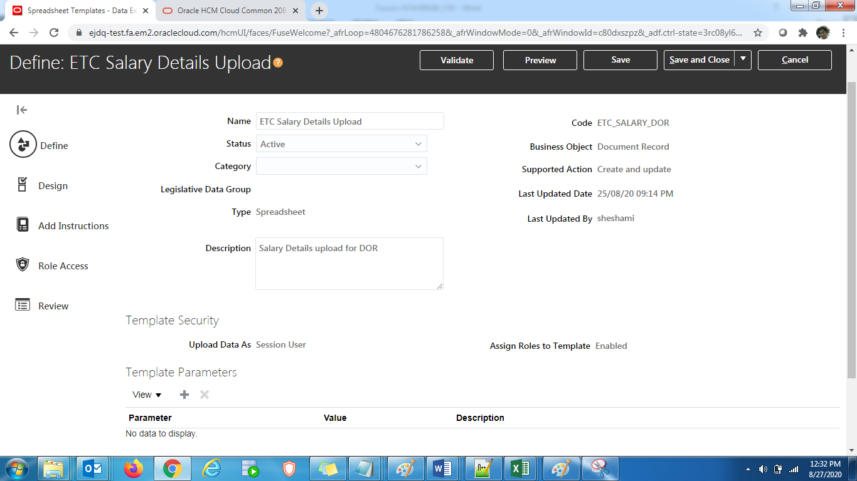

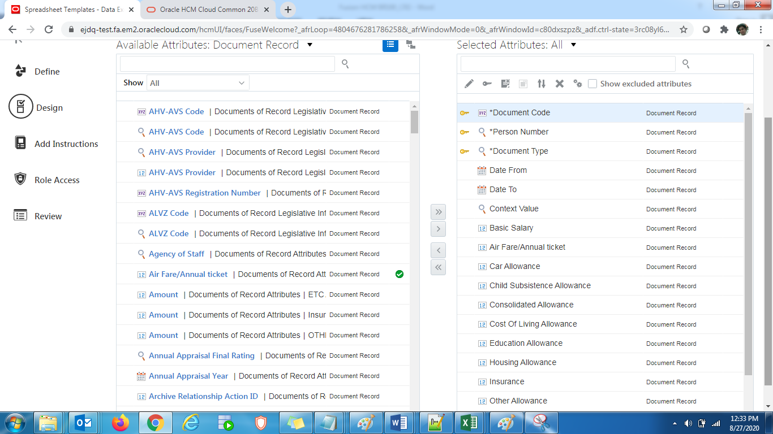

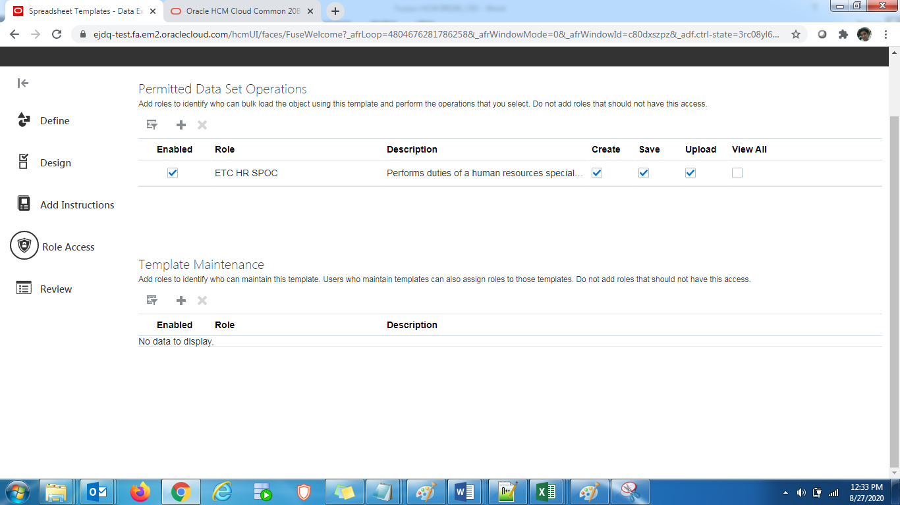

Validate > Save and Close

HSDL: ETC Adhoc Payments Upload

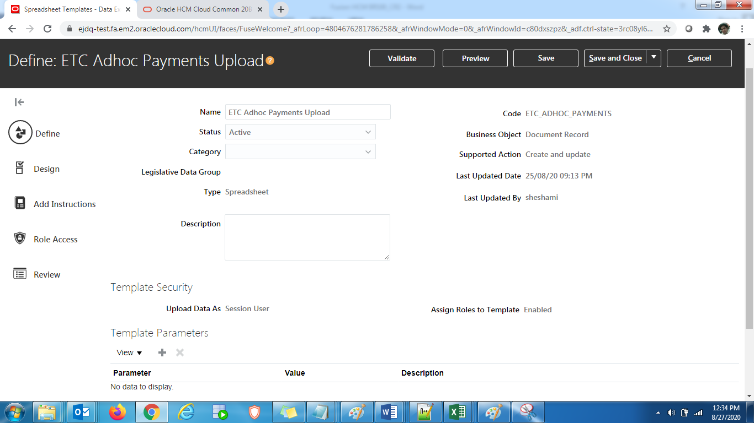

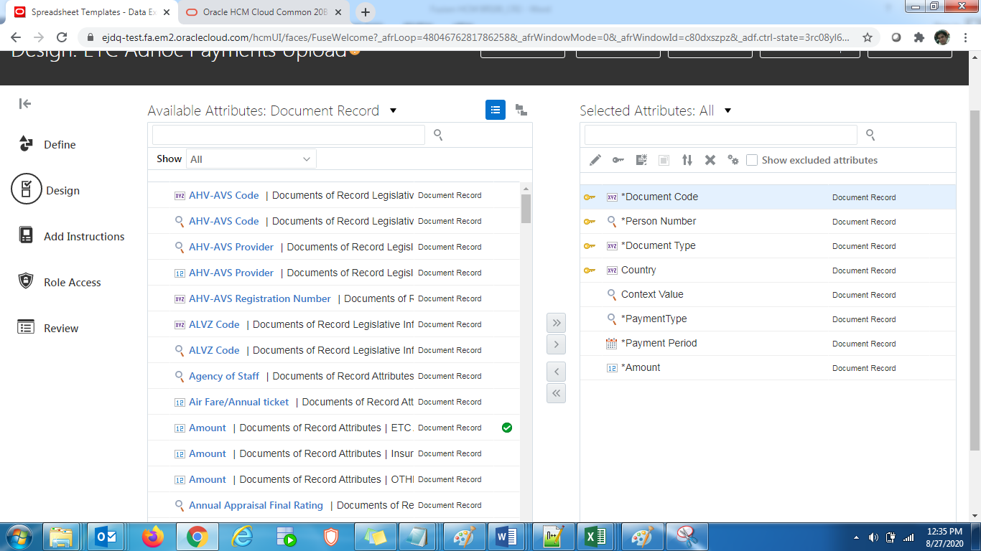

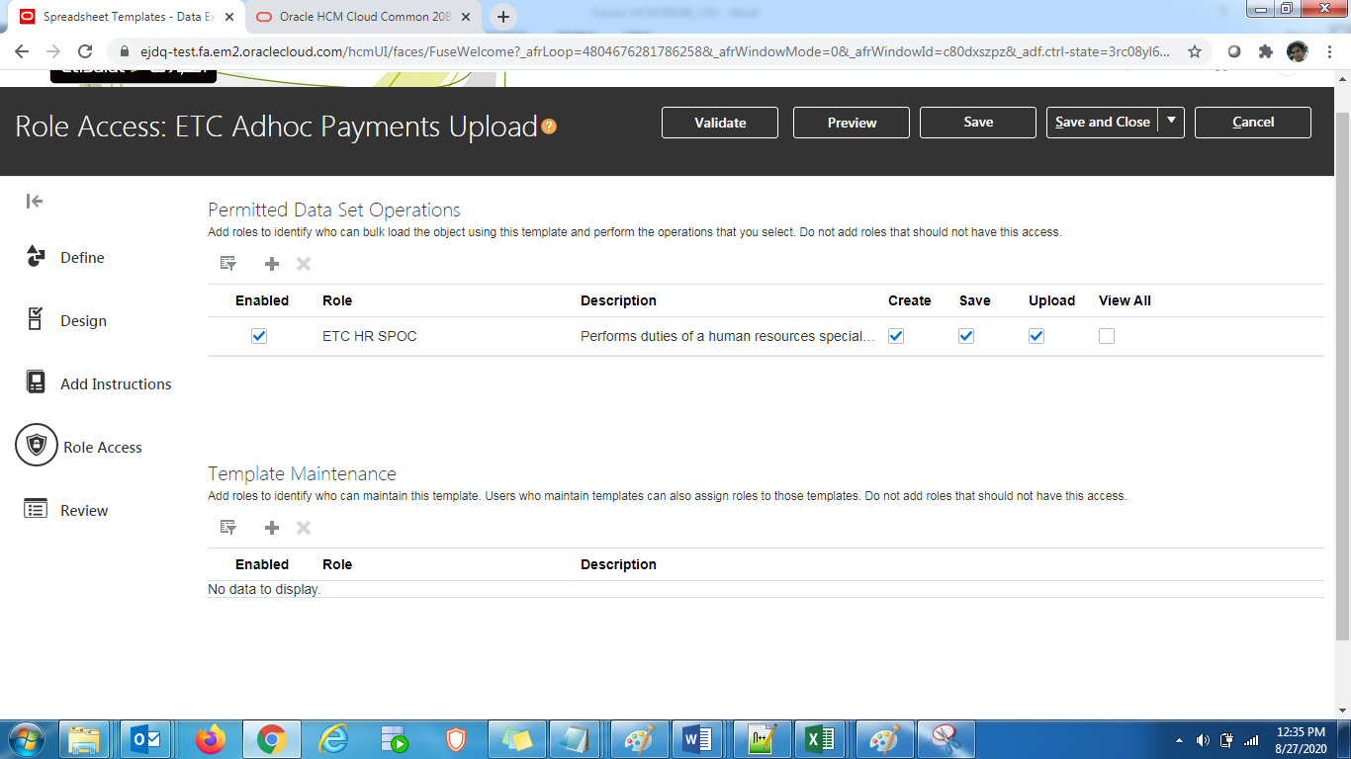

Validate > Save and Close

HSDL security details:

Add below in ETC HR SPOC role (Role Hierarchy)

|  |  |
| --- | --- |
| Add | Load Data Using HCM Spreadsheet Data Loader |
| Add | Access HCM Spreadsheet Data Loader Templates |

Add below Functional Security in ETC HR SPOC role

|  |  |
| --- | --- |
| Add | Manage Data Exchange Work Area |

Remove below Privilege from ETC HR SPOC role if added and also from any HRSPOC role if added (Role Hierarchy)

|  |  |
| --- | --- |
| Remove | HCM Spreadsheet Data Loader Data Set Administration |

## Accrual Changes for New joiners

Navigation: Navigate to setup and maintenance > Tasks > Search > Define Fast Formulas > Fast Formulas

Fast formula name: ETC_ABSENCE_ACCRUAL_MATRIX_FF

Note : Incomplete waiting for Arun’s inputs